Lab Evaluation:

Course Name: Object Oriented Programming |  |  |  | Course Code: CMPE 221L
Assignment Type: Lab |  |  |  | Dated: 1-7-2026
Semester: 2rd |  |  |  | Session: 2025
Lab/Project/Assignment #: 5 |  |  |  | CLOs to be covered: CLO1
Lab Title: Working with Classes, Objects, Constructors, and User Input in Java |  |  |  | Teacher Name: Hafiz Muhammad Mubashar
CLO1 | Implement abstraction and encapsulation to develop reusable classes for objects of real-world problems
Levels (Marks) | Level1 | Level2 | Level3 |  | Level4 | Level5 | Level6
(10)
Total |  |  |  |  |  |  | /10

Rubrics for Current Lab Evaluation
Scale | Marks | Level | Rubric
Excellent | 9-10 | L1 | Submitted all lab tasks, BONUS task, have good understanding.
Very Good | 7-8 | L2 | Submitted the lab tasks but have good understanding
Good | 5-6 | L3 | Submitted the lab tasks but have weak understanding.
Basic | 3-4 | L4 | Submitted the lab tasks but have no understanding.
Barely Acceptable | 1-2 | L5 | Submitted only one lab task.
Not Acceptable | 0 | L6 | Did not attempt

LAB No. 5
Lab Goals/Objectives:

• Getting Started with Java
• Acquiring practice with familiar programming constructs in JAVA

University Of Engineering and Technology, Lahore Computer Engineering Department
Equipment Required: Inteli J IDEA Edition Community, Net Beans with JDK 13 Version, Visual Studio.
Theory/Relevant Material: Write First Java Program
- Write a Java program to calculate the area of a circle using a predefined radius. Display the calculated area as both a floating-point value and an integer valueby using explicit type casting.

2 .Write a Java program that demonstrates the use of a parameterized constructor. Create a StudentData class to initialize a student's name, roll number, and score through the constructor, and display the student's name using a getter method.

3. Write a Java program that accepts the total marks and obtained marks from the user, calculates the percentage, and displays the result. Implement the solution using a separate class with setter methods and a calculation method.

TASK 1:
public class circleRadius {
public static void main(String[] args) {
double rad = 3442.23;
double computedArea = Math.PI * rad * rad;

System.out.println("Computed Circle Area: " + computedArea);
System.out.println("Circle Area (as Integer): " + (int) computedArea);
}
}

RESULT:
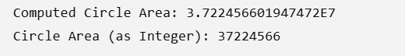

TASK 2:
class StudentData {
private String fullName;
private int rollNum;
private float score;

public StudentData(String studentName, int id, float points) {
this.fullName = studentName;
this.rollNum = id;
this.score = points;
}

public String fetchName() {
return this.fullName;
}
}

public class Const_ {
public static void main(String[] args) {
StudentData student = new StudentData("umair", 12, 14.0f);
System.out.println(student.fetchName());
}
}

RESULT:



TASK 3:
import java.util.Scanner;

public class marks_ {
public static void main(String[] args) {
Scanner inputReader = new Scanner(System.in);

System.out.println("Enter Total Marks:");
double maxScore = inputReader.nextDouble();

System.out.println("Enter Obtained Marks:");
double userScore = inputReader.nextDouble();

ResultCalculator report = new ResultCalculator();
report.assignMax(maxScore);
report.assignObtained(userScore);
report.computeAndPrint();
}
}

class ResultCalculator {
private double maxMarks;
private double scoreObtained;

public void assignMax(double total) {
this.maxMarks = total;
}

public void assignObtained(double marks) {
this.scoreObtained = marks;
}

public void computeAndPrint() {
double finalPercentage = (this.scoreObtained / this.maxMarks) * 100;
System.out.println("Percentage calculated: " + finalPercentage + "%");
}
}

RESULT:
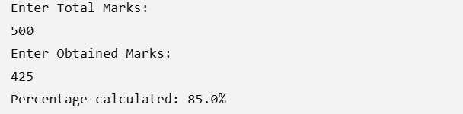

CONCLUSION:
These programs demonstrate the basic concepts of Java programming, including arithmetic operations, type casting, constructors, classes and objects, encapsulation, user input, and method implementation. They show how to calculate the area of a circle, initialize object data using a parameterized constructor, and compute a student's percentage using separate methods and classes. Overall, these programs help develop a strong understanding of object-oriented programming principles and provide a solid foundation for creating simple and efficient Java applications.

